Networking Concepts
NAT, SNMP, and VPN
Easy study notes made from Lecture 11

1. NAT (Network Address Translation)

1.1 Public IP vs Private IP
Every device that connects directly to the Internet needs a public IP address. A public IP address is unique across the whole world.
But there are not enough public IP addresses for every device. This is called an IP address shortage.
To solve this, we use private IP addresses inside small networks, like a home or office. These addresses are not unique. Many different networks can use the same private IP address.
Three ranges of IP addresses are kept only for private use:
- 10.0.0.0 to 10.255.255.255
- 172.16.0.0 to 172.31.255.255
- 192.168.0.0 to 192.168.255.255
When a device with a private IP wants to use the Internet, its private IP is mapped (changed) to a public IP. This mapping is done by NAT.

1.2 What is NAT?
NAT stands for Network Address Translation.
NAT changes a private IP address into a public IP address, and changes it back for the reply. This lets many devices with private IPs share a smaller number of public IPs.
NAT exists mainly because there are not enough IPv4 public addresses for every device in the world.
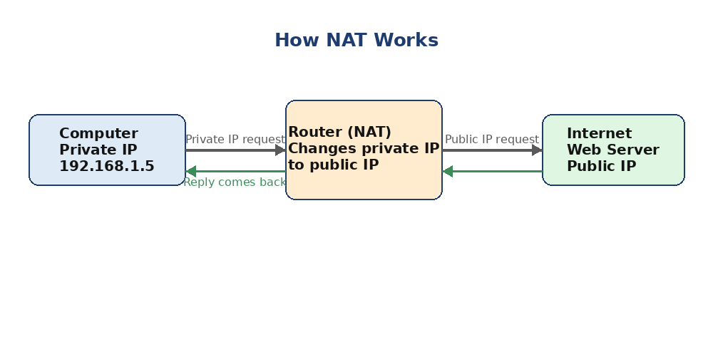
Figure 1: A simple example of how NAT changes a private IP to a public IP

1.3 Types of NAT
- Static NAT: One private IP is always mapped to the same one public IP. It is a fixed, one-to-one mapping.
- Dynamic NAT: Many private IPs share a pool (group) of public IPs. The mapping can change each time.
- Port Address Translation (PAT): A special kind of dynamic NAT. It maps a public IP and a port number to a service on a private IP. This lets many devices share just one public IP at the same time.
Note: PAT is why your whole house can use one public IP address, even with many devices online.

2. SNMP (Simple Network Management Protocol)

2.1 What is SNMP?
SNMP is a set of tools and rules (a framework) used to manage and monitor network devices, like routers, switches, and servers, over the Internet.
SNMP has four main parts:
- SNMP Agent: Software that runs on the managed device.
- SNMP Manager: Software used by the network administrator to check and control devices.
- Management Information Base (MIB): A database that stores information about the device.
- SNMP Protocol: The set of rules used to send messages between the manager and the agent.

2.2 How SNMP Works: Manager and Agent
SNMP works using a manager and agent model.
- The Manager is the link between the human administrator and the management system.
- The Agent is the link between the manager and the actual device being managed.
- The MIB is the database that both the manager and agent use to read and store values.
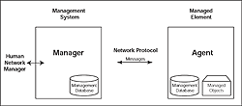
Figure 2: The SNMP manager and agent model

2.3 SNMP Messages
SNMP uses five basic messages to send information between the manager and the agent:
- GET: The manager asks the agent for the value of one variable.
- GET-NEXT: The manager asks the agent for the value of the next variable.
- GET-RESPONSE: The agent replies with the value, or an error if it cannot answer.
- SET: The manager asks the agent to change the value of a variable. The agent replies with GET-RESPONSE to confirm or show an error.
- TRAP: The agent sends this message on its own, without being asked, to warn the manager about an important event.
Note: GET, GET-NEXT, and SET all come from the manager. GET-RESPONSE and TRAP come from the agent.

3. VPN (Virtual Private Network)

3.1 What is a VPN?
A VPN is a private connection between two systems or networks that is built over a shared or public network, usually the Internet.
VPN technology lets an organization safely extend its private network over the Internet. This helps remote workers, branch offices, and partner companies connect securely.
In simple words, a VPN turns the public Internet into a private network that only the right people can use.
VPNs are popular because the Internet is available almost everywhere, and using a VPN is now normal practice for many users and companies.
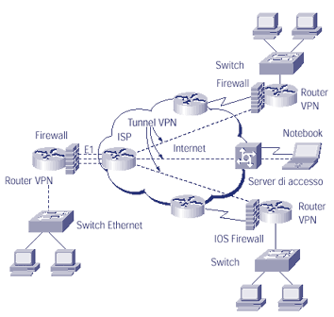
Figure 3: A VPN connects networks or users through the Internet

3.2 Problems VPN Must Solve
To use the Internet as a private network, two problems must be solved:
- Different protocols: Networks may use protocols like IPX or NetBEUI, but the Internet only understands TCP/IP. So the VPN must find a way to send non-TCP/IP data across the Internet.
- No privacy: Normally, data on the Internet travels as clear text. Anyone watching the traffic can read it. This is unsafe for private company data.

3.3 How VPN Works: Tunneling
VPN solves these problems using a method called tunneling.
In tunneling, data is first encrypted (locked with a code) for safety. Then it is placed inside a normal IP packet. This packet then travels through the Internet like a tunnel.
The tunnel has two ends:
- Tunnel initiator: Starts the tunnel from the source network and encrypts the data.
- Tunnel terminator: Receives the tunnel at the destination network.
Both ends agree on an encryption method before sending data, so the tunnel stays secure.

3.4 Advantages of VPN
- Lower cost: No need to buy expensive leased lines to connect branch offices or partners.
- Uses existing Internet setup: No need to invest in extra WAN (Wide Area Network) equipment.
- Good for mobile users: Employees who travel or work remotely can connect safely from anywhere.

